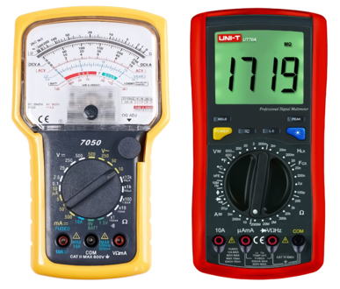SELF-DIRECTED LEARNING

READING SCALES

During Course 1 you will be using meters to measure current, voltage and resistance. It is important you can accurately read scales since not all equipment is digital.

**To determine the value of each little mark between numbered values in a scale reading, find the difference between successively numbered values then divide by the number of spaces**.

Example:

|  |  |
| --- | --- |
|  | Difference between 20 and 30 is 30 – 20 = 10  Number of spaces between 20 and 30 is 10  \ each interval = 10 ¸ 10 = 1 |
|  | Difference between 5 and 6 is 6 – 5 = 1  Number of spaces between 5 and 6 is 10  \ each interval = 1 ¸ 10 = 0.1 |
|  | Difference between 100 and 200 is 200 – 100 = 100  Number of spaces between 100 and 200 is 5  \ each interval = 100 ¸ 5 = 20 |

H5P link for activity:

|  |  |
| --- | --- |
|  | https://tinyurl.com/yc3t89a9 |

<https://tinyurl.com/64nkwu44>

Find the readings marked A – D on the following scale. (Write your answers as decimal numbers in the boxes on the right.)

|  |  |
| --- | --- |
| A = |  |
| B = |  |
| C = |  |
| D = |  |

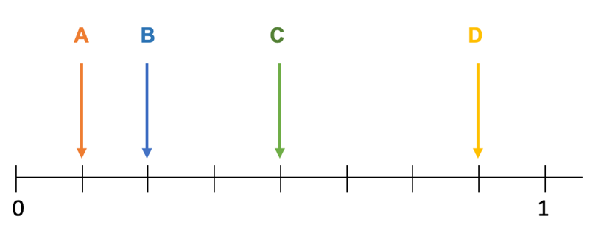

What is the reading on each of the following scales? Write your answer in the space provided to 2 significant figures. (Check the meaning of significant figures if you are not sure.)

|  |  |
| --- | --- |
|  |  |
| oC | oF  oC |
| 1. Speedometer | 1. Calendar, circle     Description automatically generated |
| m/h km/h | oF |
| 1. http://biology.clc.uc.edu/fankhauser/labs/microbiology/Growth_Curve/spectrophotometer/15_read_specimen_2_P7131138.jpg | 1. http://biology.clc.uc.edu/fankhauser/labs/microbiology/Growth_Curve/spectrophotometer/14_read_specimen_1_P7131142.jpg |
| (T) (A) | (T) (A) |

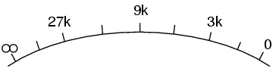Not all scales are linear (decibels and ohms are two examples). You should still apply the previous rules when taking your readings however.

Find the readings on the following displays beginning with the outer scale and working inwards. (Choose your answers from the bank of numbers to the correct reading.)

|  |  |  |  |
| --- | --- | --- | --- |
| How to Determine Digital Multimeter Accuracy | **Scale** | **Reading** | **Unit** |
| Resistance |  | W |
| 250DCV |  | V |
| 50ACV |  | V |
| Current |  | mA |
| Sound pressure |  | dB |

|  |  |  |  |
| --- | --- | --- | --- |
| Analog Ohmmeter Photos - Free & Royalty-Free Stock Photos from Dreamstime | Resistance |  | W |
| 25ACV |  | DCV |
| 10ACV |  | ACV |
| 2.5ACV |  | mA |
|  | | | |
| Can You Trust Your Voltmeter? | Nuts & Volts Magazine | Resistance |  | W |
| 150AC |  | V |
| 300DC |  | V |
| 60DC |  | V |
| 12DC |  | V |
| 3AC |  | V |
| 1.5AC |  | V |
| Sound pressure |  | dB |

**Number Bank**

|  |  |  |  |  |
| --- | --- | --- | --- | --- |
| 21 | 14 | 0.9 | 220 | 3.8 |
| 49.8 | 6.9 | 0.55 | 50 | 1.18 |
| 122 | 1.35 | 9.9 | 134 | 8.8 |
| 2.5 | 10.25 | 44 | 249 | 8.4 |